AWS Cloud Security Assignment – Unit 4

Windows Server EC2 Deployment, Remote Access and Security Verification
Student Name: Manasvi Tripathi
Roll Number: 2124UCSF1104
Department: Cyber Security
University: Sanjivani University
Subject: Cloud Security

1. Aim
To launch a Windows Server instance on Amazon Web Services (AWS), establish remote access using Remote Desktop Protocol (RDP), examine Windows system information, create a local user account, verify Windows Defender Firewall, and understand the security configurations required to protect a cloud-based Windows server.

2. Objectives
- Launch a Windows Server virtual machine using Amazon EC2.
- Configure a security group to control remote access.
- Connect to the Windows Server using Remote Desktop Protocol.
- View Windows operating system and hardware information.
- Create a local Windows user account.
- Verify the status of Windows Defender Firewall.
- Create a text file on the Windows Server.
- Understand secure access and basic network troubleshooting in AWS.

3. Tools and Technologies Used
Tool/Technology | Purpose
Amazon Web Services (AWS) | Cloud computing platform
Amazon EC2 | Creation and management of the virtual machine
Windows Server | Server operating system
Remote Desktop Protocol (RDP) | Remote access to the Windows desktop
AWS Security Groups | Control of inbound and outbound network traffic
Windows Defender Firewall | Protection against unauthorized network connections
PowerShell | Verification of firewall status and network connectivity
Windows System Information | Display of operating system and hardware details

4. Procedure

Step 1: Launching a Windows Server EC2 Instance
Amazon EC2 was used to create a virtual Windows Server instance.
The following steps were performed:
- Logged in to the AWS Management Console.
- Opened the Amazon EC2 service.
- Selected the Asia Pacific (Mumbai) region (ap-south-1).
- Selected a Windows Server Amazon Machine Image (AMI).
- Configured the instance name as Unit4-Windows-Server.
- Selected an appropriate instance type.
- Selected or created a key pair for retrieving the initial Windows Administrator password.
- Configured the network settings and security group.
Launched the instance.
After launching, the instance entered the Running state, and its EC2 status checks passed.

Step 2: Configuring the Security Group
A security group was configured to control network access to the Windows Server instance.
The inbound rule was configured as follows:
Parameter | Configuration
Type | RDP
Protocol | TCP
Port Range | 3389
Source | My IP
Purpose | Allow remote desktop access from the authorized public IP address
Port 3389 is the default port used by Remote Desktop Protocol.
Restricting the source to the user's public IP address reduces exposure to unauthorized remote connection attempts. RDP should not be exposed to all IPv4 addresses (0.0.0.0/0).

Step 3: Connecting to Windows Server Using RDP
Remote Desktop Protocol was used to access the Windows Server instance.
The following steps were performed:
- Selected the Windows instance in the EC2 console.
- Clicked Connect.
- Opened the RDP client tab.
- Retrieved the initial Windows Administrator password using the corresponding private key file.
- Opened Remote Desktop Connection on the local computer by running mstsc.
- Entered the public IPv4 address of the EC2 instance.
- Entered the Administrator username and decrypted password.
- Established the remote connection.
The Windows desktop opened successfully, confirming that the initial remote connection was established.

Step 4: Checking Windows System Information
The Windows System Information utility was opened to examine the operating system and hardware configuration.

Procedure
- Pressed Windows + R.
- Entered the command:
msinfo32
- Pressed Enter.
- The System Information window opened.
This utility displays information such as:
- Operating system name and version.
- System manufacturer and model.
- System type.
- Processor information.
- Installed physical memory.
- BIOS information.
This information helps identify the operating environment and verify the system configuration.

Step 5: Creating a Local Windows User Account
A local user account named LabUser was created on the Windows Server.

Procedure
- Pressed Windows + R.
- Entered:
compmgmt.msc
- Opened Local Users and Groups.
- Selected Users.
- Right-clicked the Users section and selected New User.
- Entered the following details:
Field | Value
User Name | LabUser
Full Name | AWS Lab User
Password | A strong password chosen by the user
- Clicked Create to create the account.
The account was successfully created.
Creating separate user accounts helps organize access and avoids unnecessary use of the Administrator account for routine activities. Appropriate permissions should be assigned according to each user's responsibilities.

Step 6: Verifying Windows Defender Firewall
Windows Defender Firewall was checked to confirm that firewall protection was enabled.

Procedure
- Pressed Windows + R.
- Entered:
wf.msc
- Opened Windows Defender Firewall with Advanced Security.
- Opened PowerShell to verify the firewall profile status.
- Executed the following command:
Get-NetFirewallProfile | Select-Object Name, Enabled
The command displays the firewall status for three profiles:
- Domain
- Private
- Public
The reported results showed that all three profiles were enabled.
Profile | Status
Domain | Enabled
Private | Enabled
Public | Enabled
An enabled firewall helps control network connections according to the configured firewall rules. It should remain enabled, and only necessary network traffic should be permitted.

Step 7: Creating a Text File on Windows Server
A text file can be created to demonstrate basic file management on the Windows Server.

Procedure
- Open the Windows Server desktop.
- Right-click an empty area of the desktop.
- Select New → Text Document.
- Name the file AWS_Unit4_Lab.txt.
- Open the file in Notepad.
- Enter the following content:
AWS Unit 4 - Windows Server Lab

Platform: Amazon Web Services
Service: Amazon EC2
Operating System: Windows Server
Remote Access: Remote Desktop Protocol (RDP)

Tasks Performed:
1. Checked Windows System Information.
2. Created a local user account named LabUser.
3. Verified Windows Defender Firewall status.

Security:
RDP access should be restricted through the AWS security group.
Windows Defender Firewall was verified as enabled.
- Save the file using Ctrl + S.

5. Network Troubleshooting
After a network interruption, the Remote Desktop connection could not be re-established.
The following checks were performed:
- Confirmed that the EC2 instance was in the Running state.
- Confirmed that the EC2 status checks had passed.
- Checked that the public IPv4 address matched the address entered in Remote Desktop Connection.
- Checked that the security group allowed RDP traffic on TCP port 3389 from the user's IP address.
- Checked the subnet route table and confirmed the presence of a default route to an Internet Gateway.
The following PowerShell command was executed on the local computer to test connectivity to the RDP port:
Test-NetConnection -ComputerName YOUR_PUBLIC_IP -Port 3389
Here, YOUR_PUBLIC_IP should be replaced with the actual public IPv4 address of the Windows Server instance.
The result was:
TcpTestSucceeded : False
This result indicates that the local computer could not establish a TCP connection to port 3389 at the time of testing.
Although the instance was running and the basic network configuration had been checked, the connection problem was not fully resolved. The Network ACL and the Windows-side RDP service and firewall path were not completely investigated.

6. Security Measures Implemented and Recommended
The following security practices are relevant to the deployment and management of the Windows Server instance:

6.1 Restricting Remote Access
RDP access should be limited to the authorized public IP address through the AWS security group. Opening port 3389 to all IPv4 addresses should be avoided.

6.2 Protecting Credentials
The Windows Administrator password and private key file (.pem) should be stored securely. These credentials should never be shared or included in screenshots.

6.3 Enabling Windows Defender Firewall
Windows Defender Firewall was reported to be enabled for the Domain, Private, and Public profiles. Keeping the firewall enabled helps protect the server from unauthorized network connections.

6.4 Monitoring Network Access
Security groups, route tables, and Network ACLs should be checked when remote connectivity problems occur. Troubleshooting should identify the cause without unnecessarily opening access to the internet.

6.5 Managing Cloud Resources
The EC2 instance should be stopped when the assignment work is finished and the required evidence has been collected. Stopping an instance generally stops its instance-running charges, but attached storage and other resources may continue to incur charges.

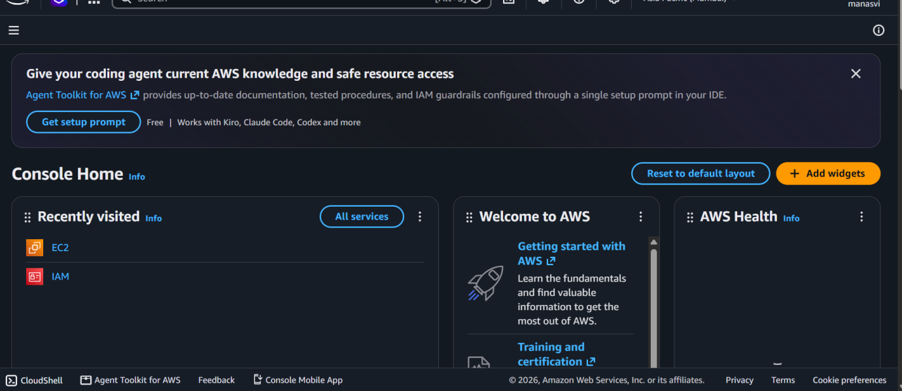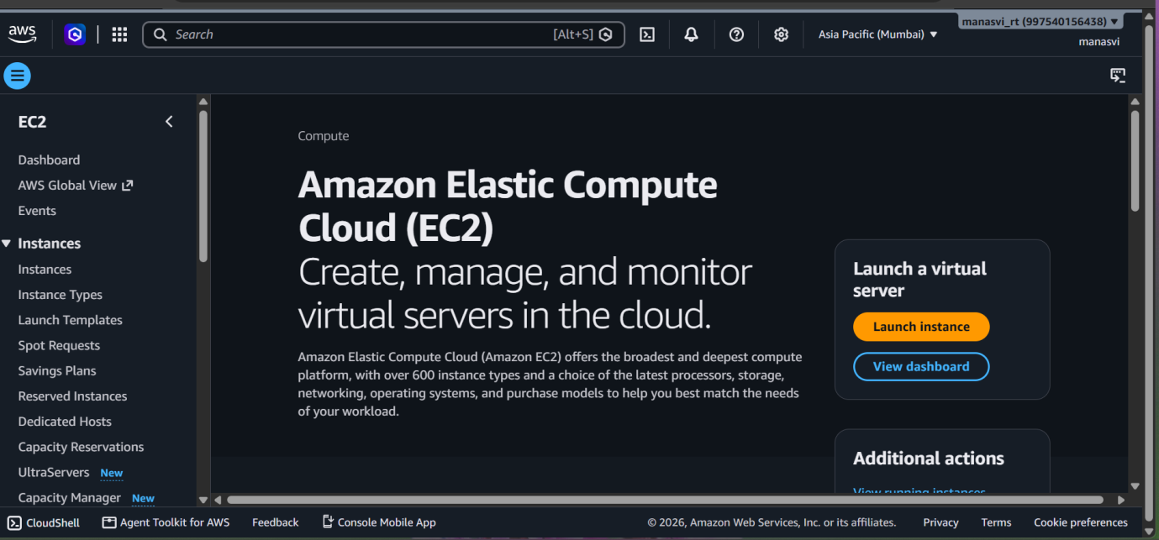
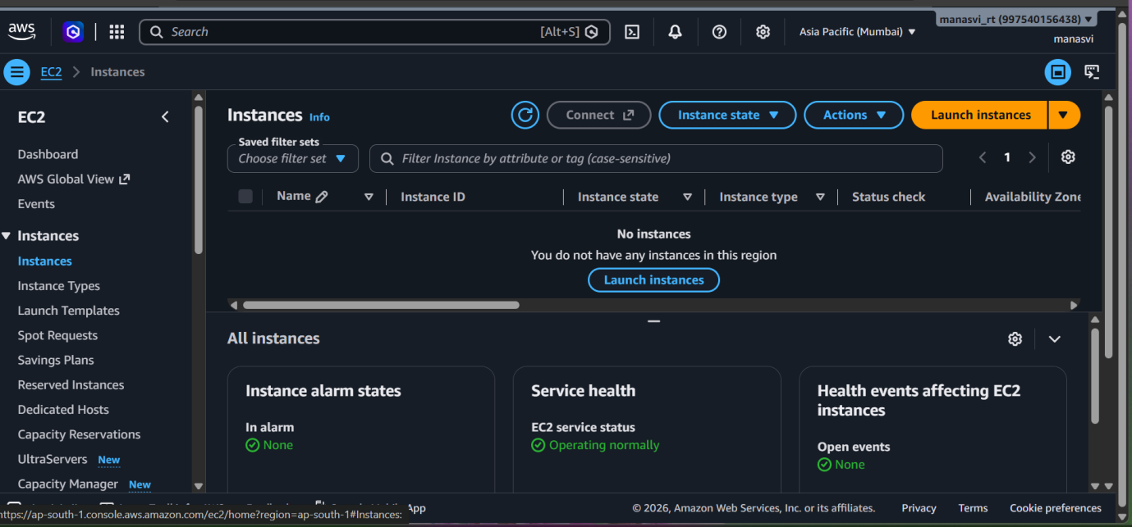
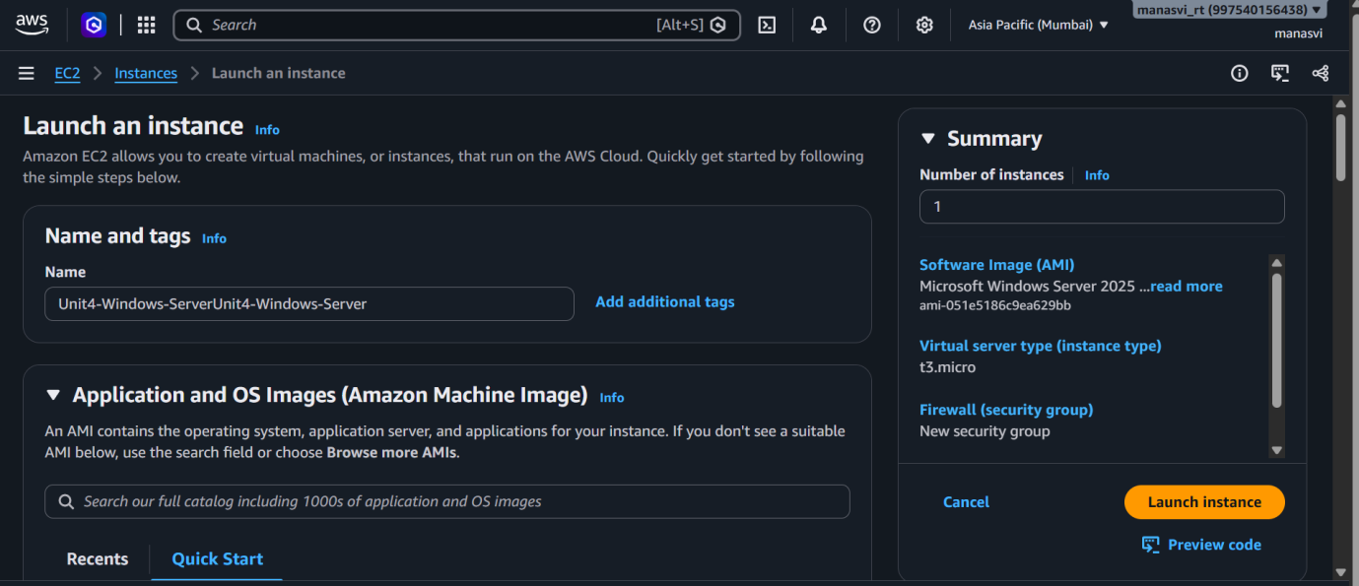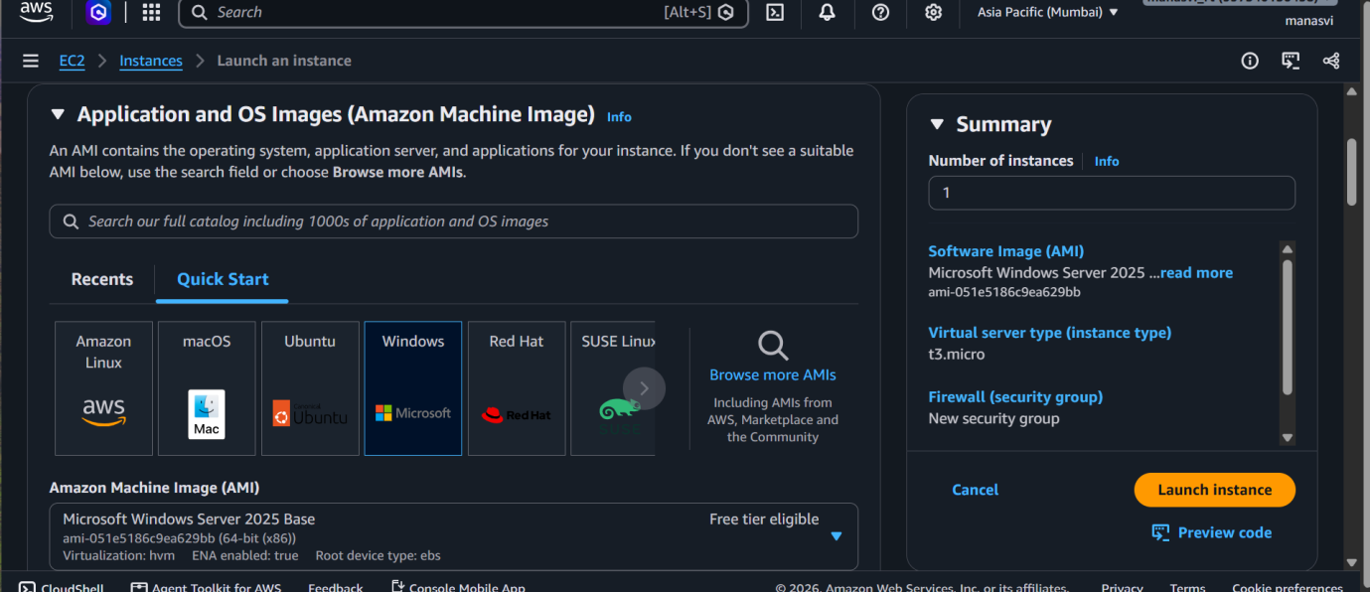
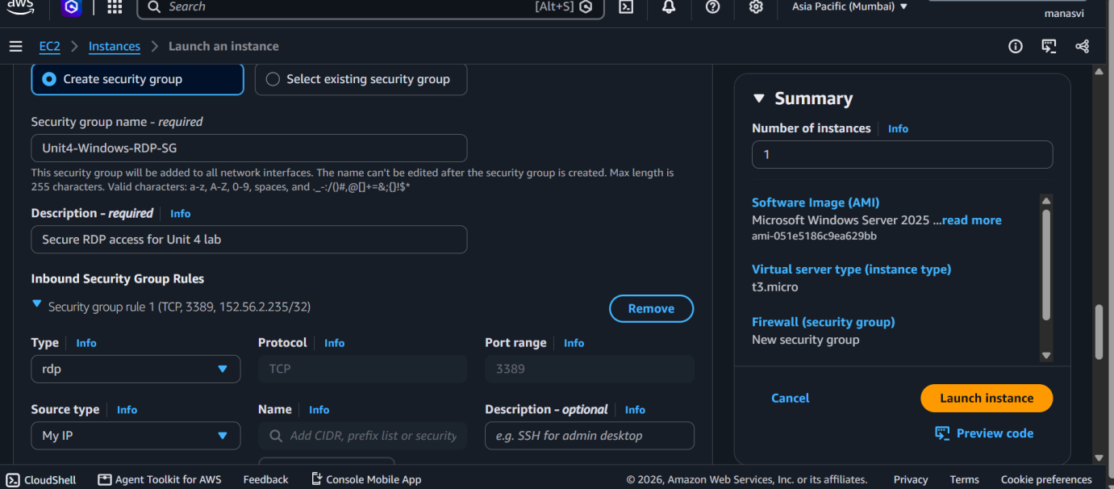
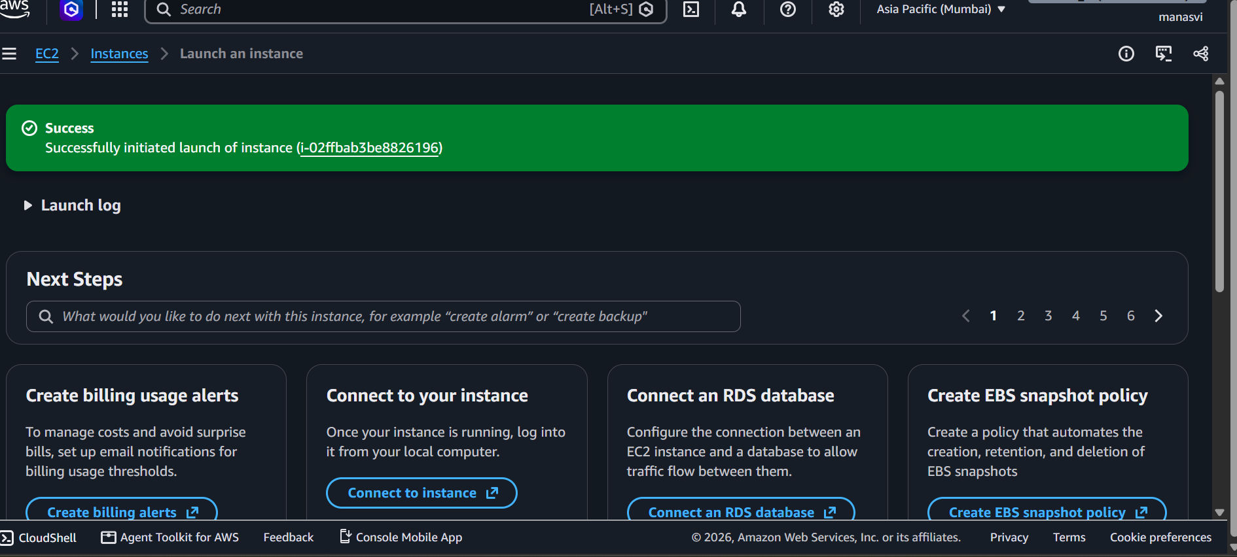
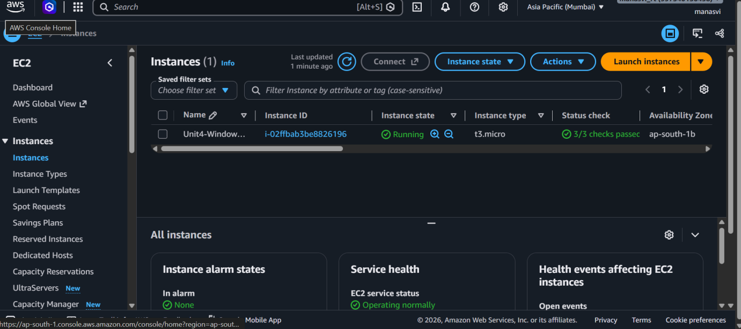

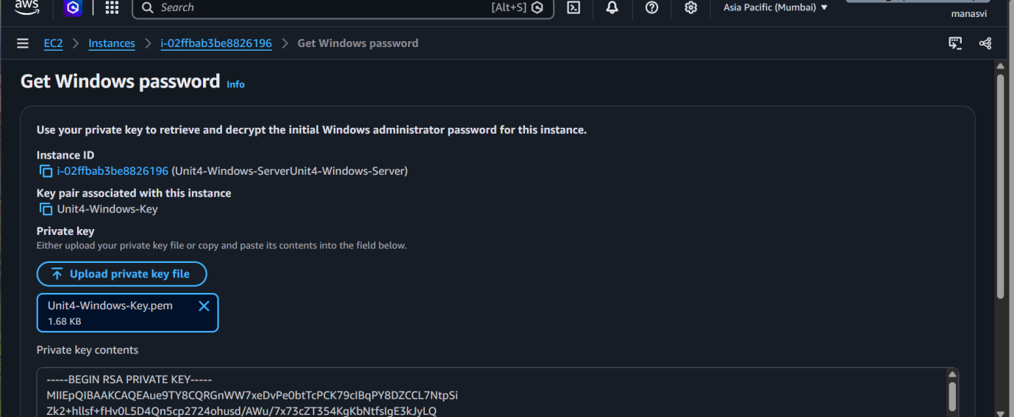
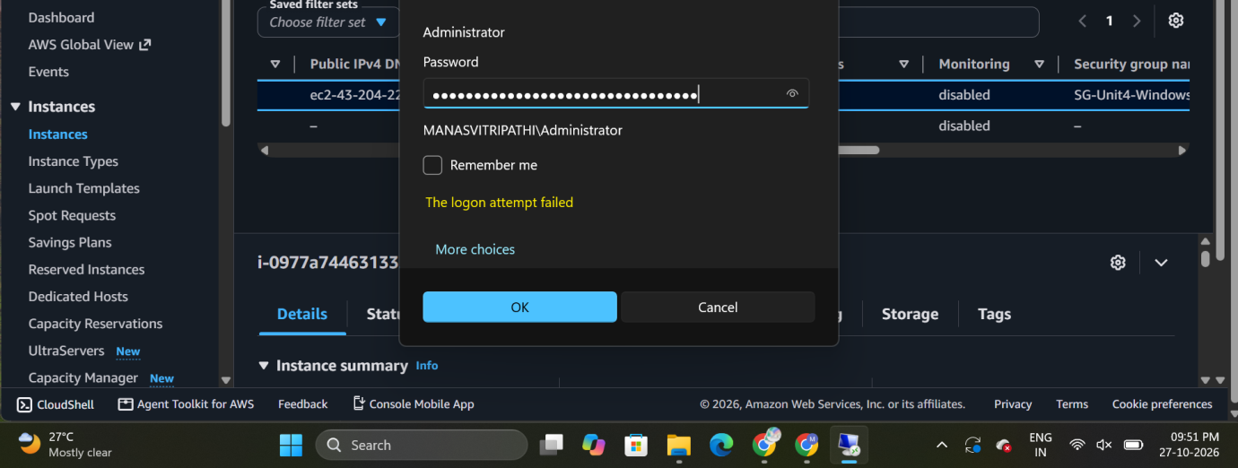
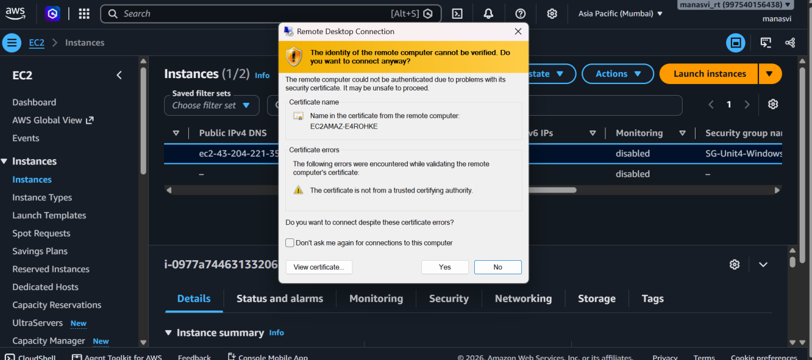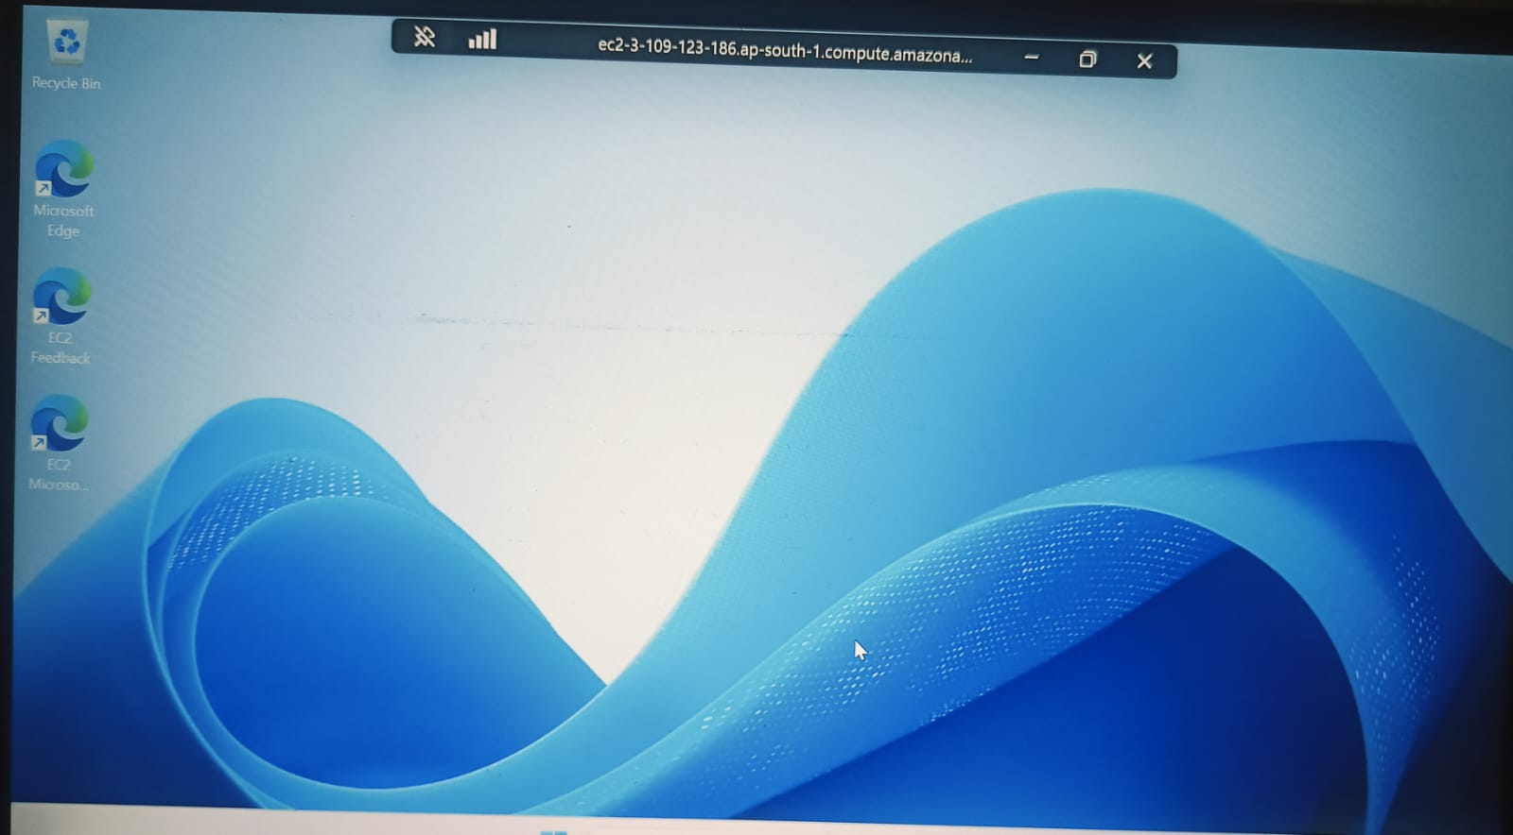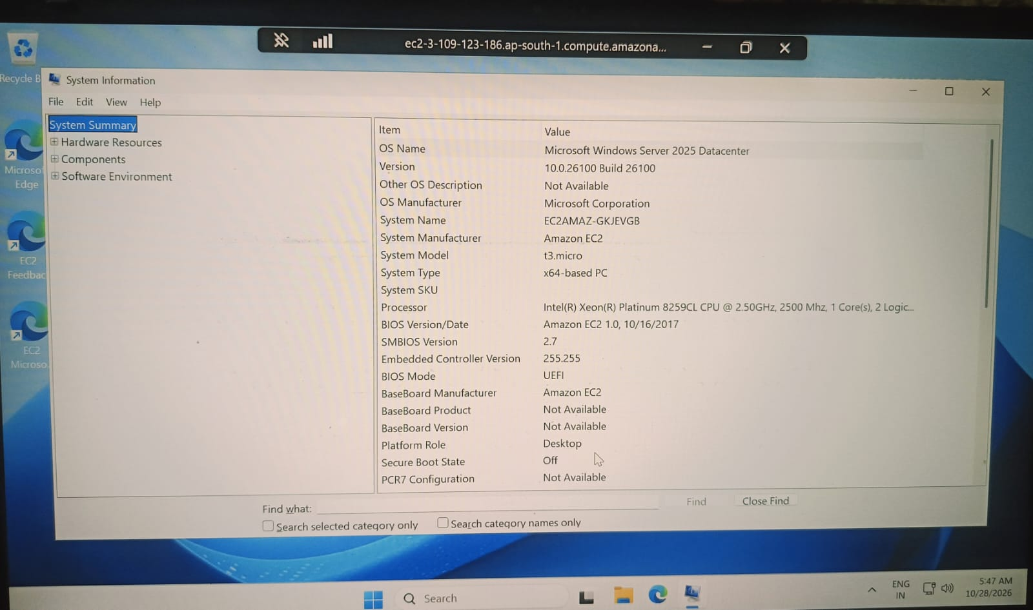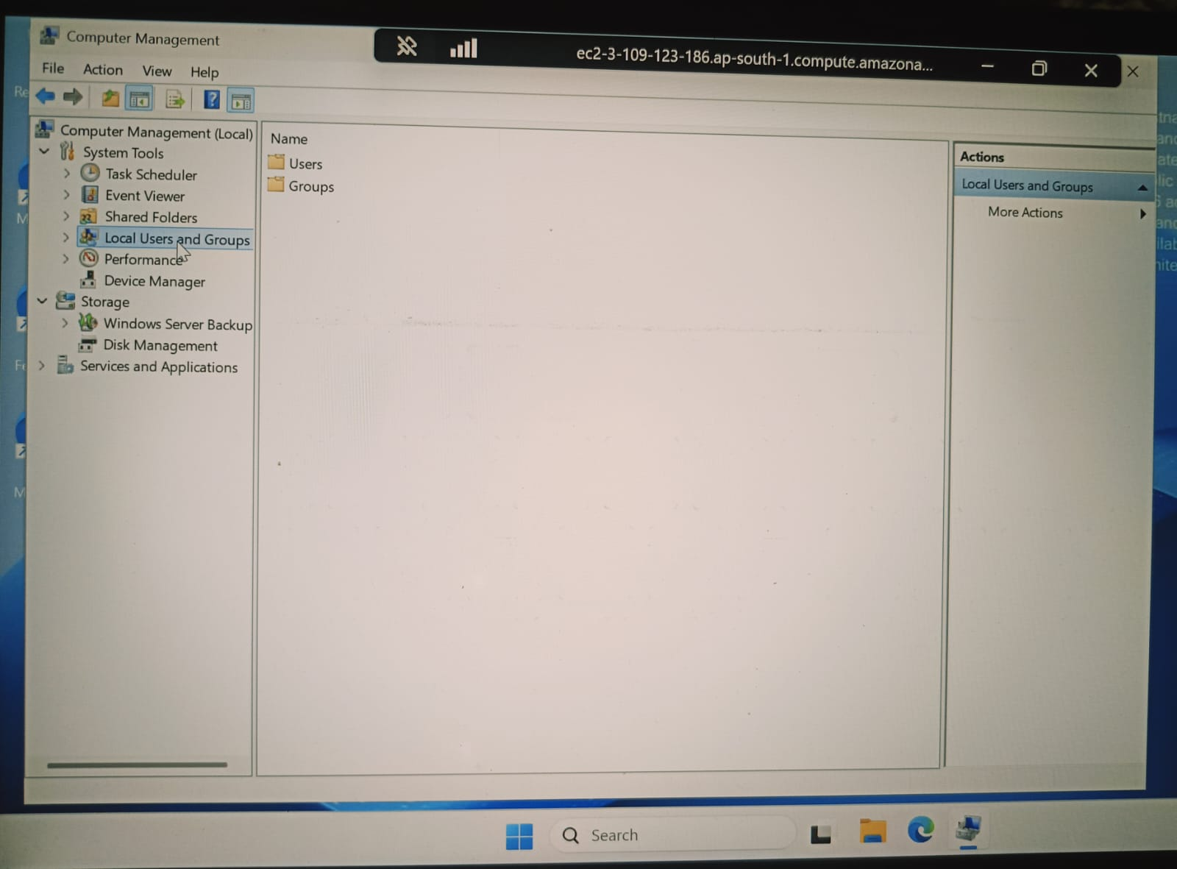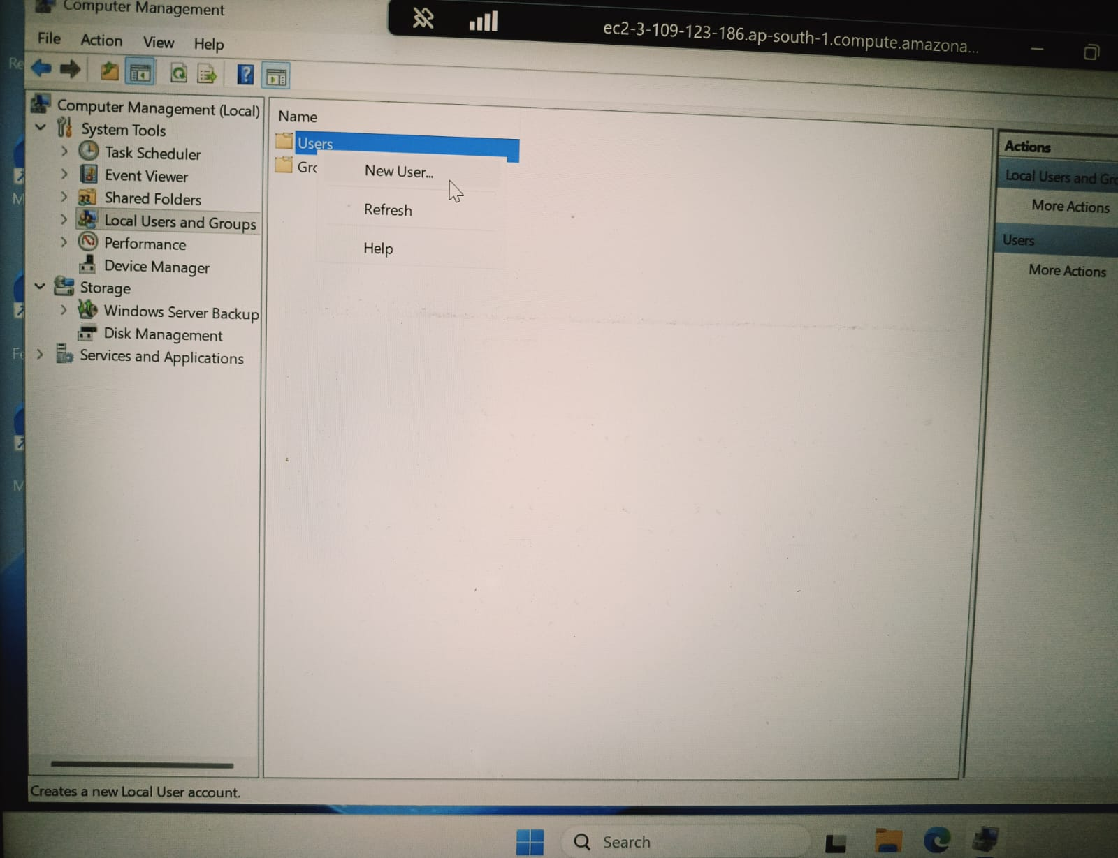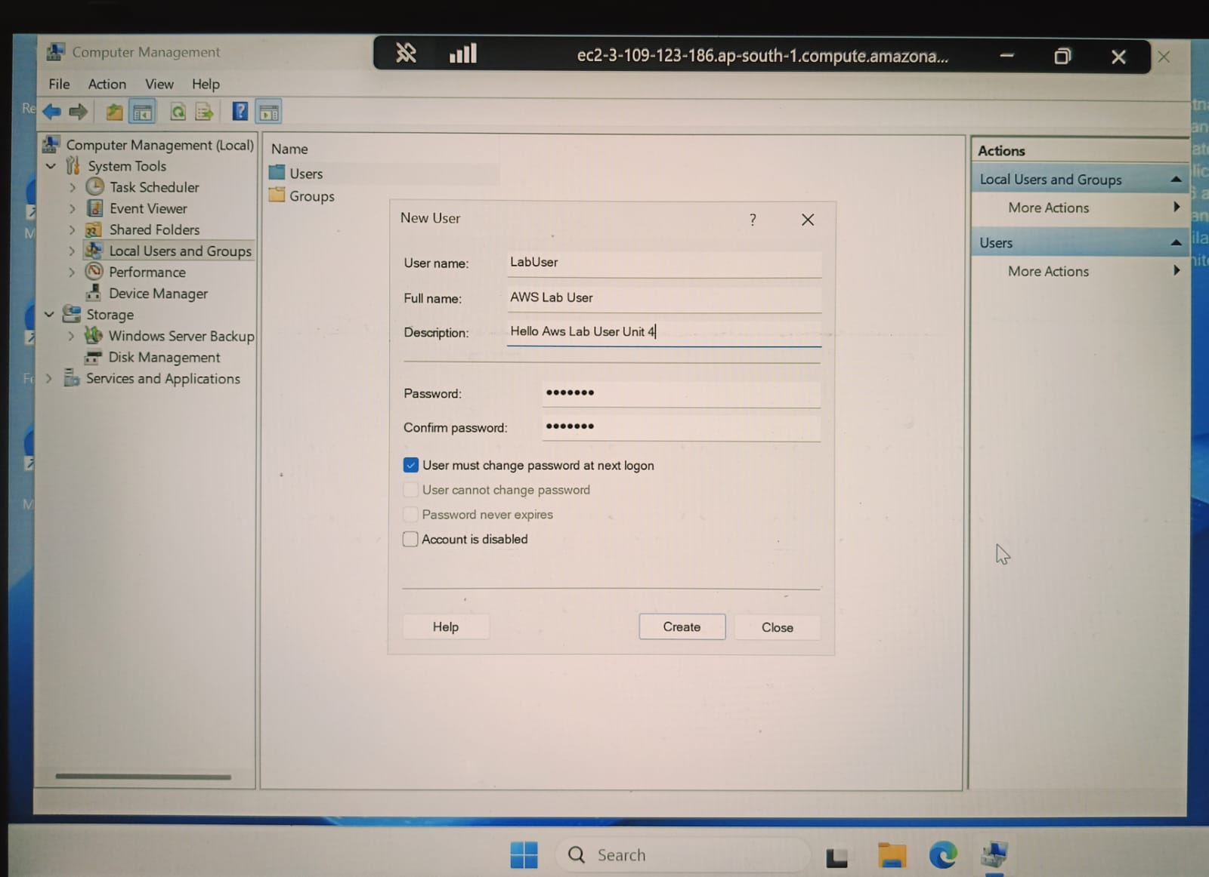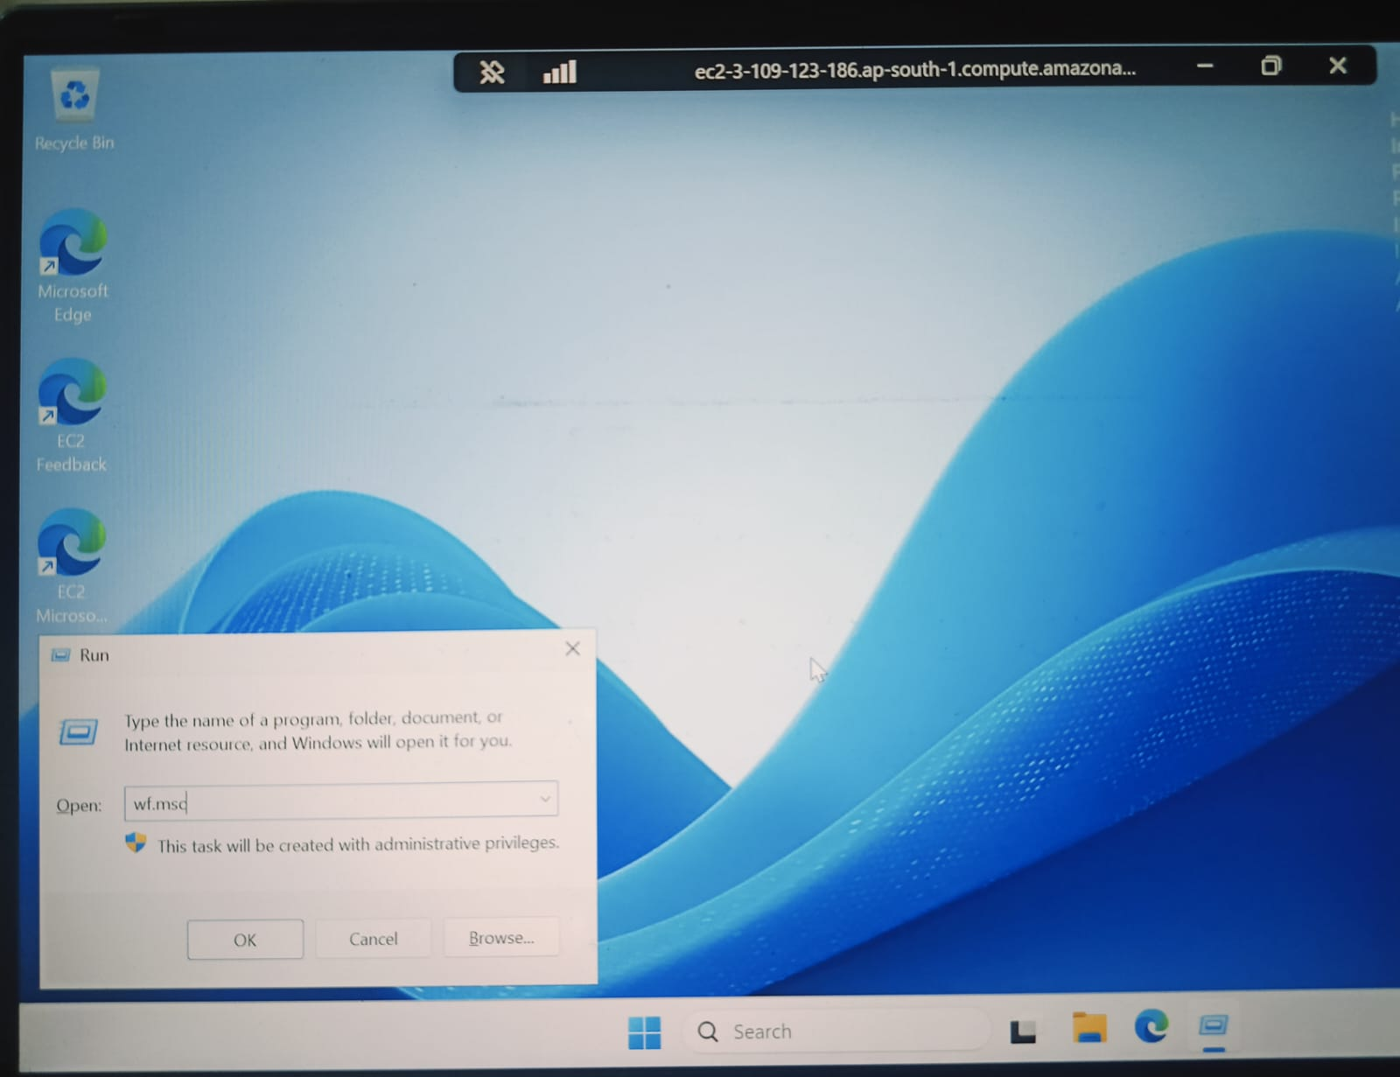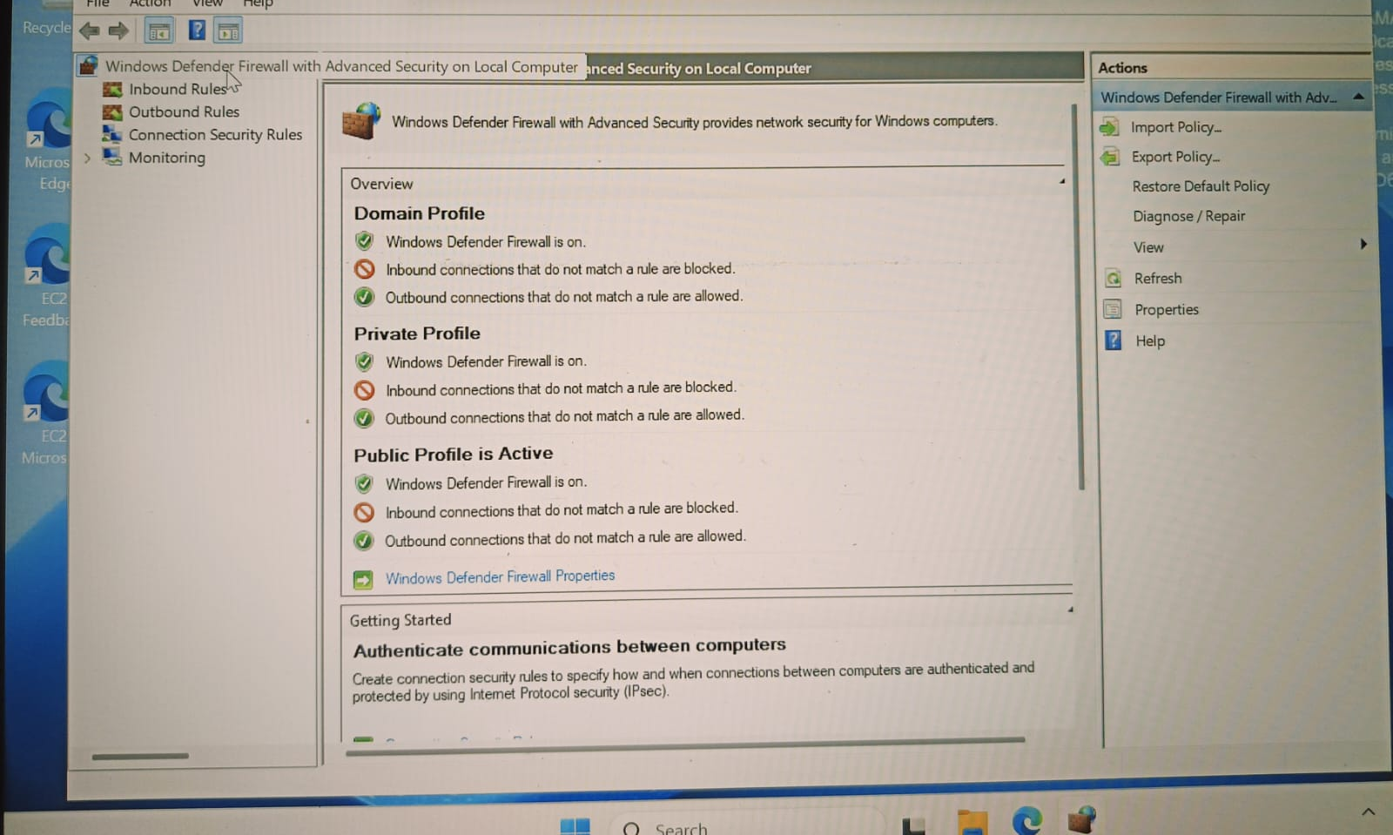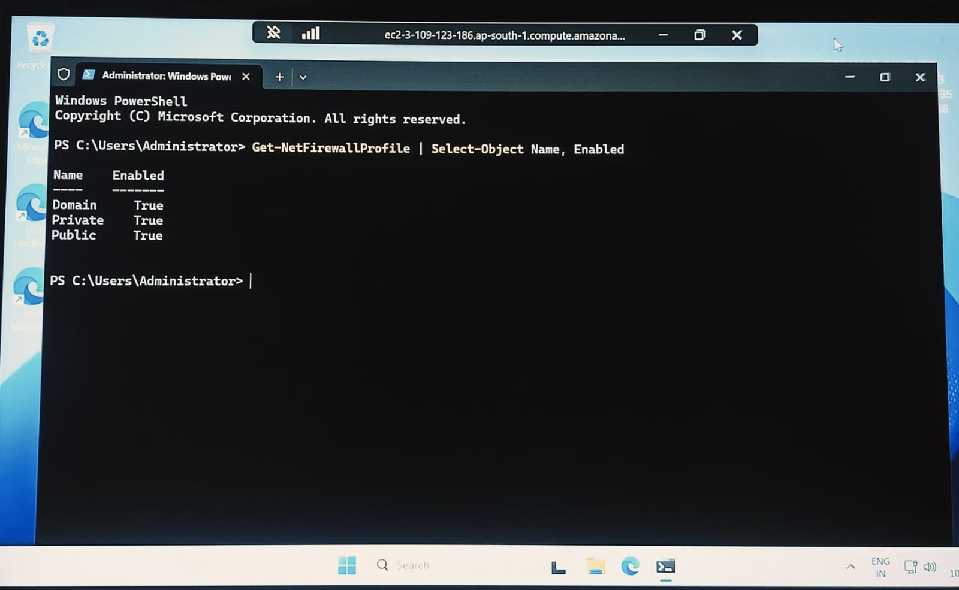

7. Conclusion
In this practical assignment, a Windows Server virtual machine was launched on Amazon EC2 and accessed successfully through Remote Desktop Protocol. The Windows System Information utility was opened, a local user account named LabUser was created, and Windows Defender Firewall was verified as enabled for the Domain, Private, and Public profiles.
After a network interruption, the RDP connection could not be restored. The instance state, public IP address, security-group rule, and Internet Gateway route were checked, but the underlying connectivity issue remained unresolved.
The practical session provided experience with cloud virtual machines, remote administration, Windows user management, firewall verification, and basic network troubleshooting. The remaining tasks include creating the text file if required, inserting the actual screenshots, completing the network investigation if necessary, and stopping the EC2 instance after collecting the required evidence.

